***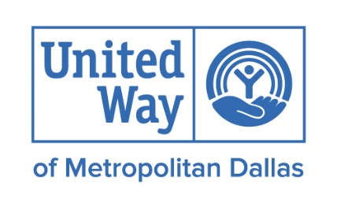*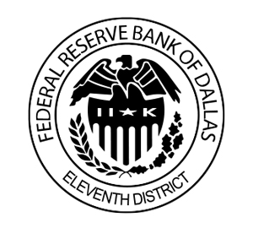**

**Iberia Bank**

**Credit Union of Texas**

**FINANCIAL INCLUSION ROUNDTABLE**

**Tuesday, April 11, 2017**

**11:30 am – 1:30 pm**

**United Way of Metropolitan Dallas**

**11:30 a.m.       Lunch and Networking**

**12:00 noon Welcome**

* + - Greg Mangum, VP, Community Financial Stability, United Way of Metropolitan Dallas

**12:10 noon      Keynote presentation: Results of the FDIC Survey on the**

**Unbanked/ Underbanked in Dallas**

* + - Eloy Villafranca, Regional Manager, FDIC Community Affairs Branch

**1:10 pm            Helping the Unbanked**

* + - Eloy Villafranca, Regional Manager, FDIC Community Affairs Branch
    - Roy Lopez, Officer, Community Development, Federal Reserve Bank of Dallas
      * + S.A.F.E. Account Template
        + CFE Fund National Account Standards

**1:25 pm            City of Dallas Updates**

* + - Councilman Rick Callahan, City of Dallas

**1:30 pm               Adjourn**

**Save the Date: Next Financial Inclusion Roundtable- September 19, 2017**

**highlighting workforce development and CRA**

**Thanks to our 2016-17 Sponsors**

[](https://www.google.com/url?sa=i&rct=j&q=&esrc=s&source=images&cd=&cad=rja&uact=8&ved=0ahUKEwjP3sqKjZzQAhVCbiYKHQeZD3oQjRwIBw&url=https://online.woodforest.com/&psig=AFQjCNHIk2wa_S9jxtSJP7rFjl62205Syg&ust=1478795598211121)